**ASSIGNMENT #4**

**Q#1:**

If the switch opens at *t* = 0, find *v(t)* for *t* ≥ 0

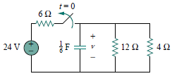

**Q#2:**

The switch in the circuit has been closed for a long time, and

it is opened at *t* = 0. Find *v(t)* for *t* ≥ 0.

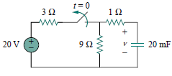

**Q#3:**

At *t* = 0, switch is closed, and switch 2 is closed 4 s later. Find *i(t)* for *t >* 0. Calculate *i* for *t* = 2 s and *t* = 5 s.

**HINT:** You need to consider the three time intervals *t* ≤ 0*,* 0 ≤ *t* ≤ 4, and *t* ≥ 4 separately.

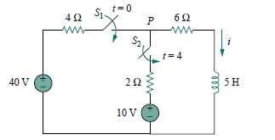

**Q#4:**

Solve the expression



**Q#5**

Using the pharos approach, determine the current *i(t)* in a circuit describedby the integrodifferential equation

